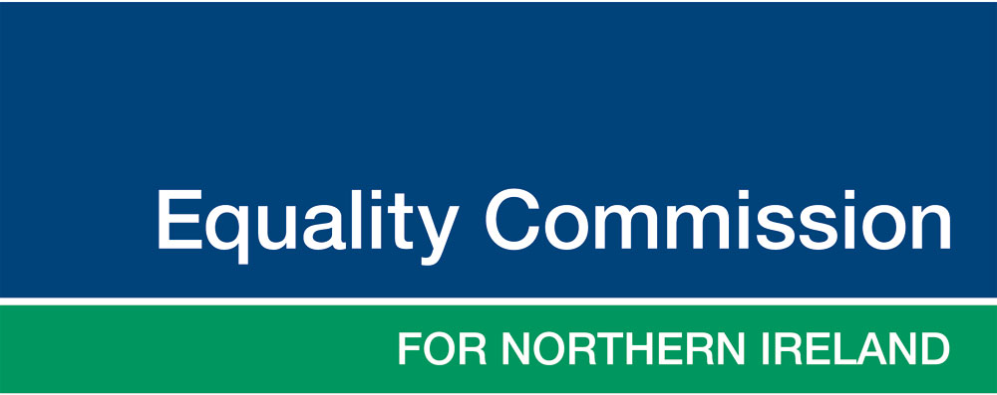

Public Consultation

Proposals to amend the Commission’s advice to public authorities on:
Timescales for consulting on matters relevant to the statutory equality and good relations duties

Closing date for responses: 5pm Monday 9 May 2016
Published: 7 March 2016

Seeking your views

This document sets out the Commission’s reasons and proposals for amending our advice to public authorities on the timescales for public consultations that are committed to in their Equality Schemes. The document is intended to inform stakeholders, enable views to be given on the proposals and gather additional data or evidence to inform the Commission’s decision.

We are consulting until Monday 9 May 2016 and would welcome your response by this date. Our aim, in setting this deadline, is to issue any updated advice to coincide with the implementation of relevant parts of the Stormont House Agreement, following the Assembly elections.

You can submit written comments on this form as a Word document, or online by completing the questions in our survey here:

- https://www.surveymonkey.co.uk/r/WTCZ85G

Consultation event

We are also planning a consultation event, which will provide the opportunity to feed back in person on the questions raised in the consultation. In addition, we would like to use the opportunity to hear about examples of effective engagement and consultation in relation to the Section 75 duties and for those groups covered by the Section 75 categories.

This event will be held in Riddell Hall, Belfast, on the morning of:

Tuesday 26 April 2016, from 10.30am

Please email section75@equalityni.org to register your interest in attending this event.

To submit your response, or for further information

If you would like any further information, information in an alternative format, or to submit your response, please contact us, as follows:

Section 75 Consultation
Equality Commission for Northern Ireland
Equality House
Shaftsbury Square
Belfast
BT2 7DP

Email: section75@equalityni.org
Telephone: 028 9050 0600
Web: www.equalityni.org

- Introduction

This document sets out the Commission’s reasons and proposals for amending our advice to public authorities on the timescales for public consultations that are committed to in their Equality Schemes. The document is intended to inform stakeholders, enable views to be given on the proposals and gather additional data or evidence to inform the Commission’s decisions.

- Background

The Commission has a responsibility to advise public authorities on the duties in Section 75 of the Northern Ireland Act. One key element of this advice is to recommend what arrangements a public authority should have in its Equality Scheme, which shows how it proposes to fulfil the duties.

(Follow this link to find out more about what Section 75 is or what the statutory equality and good relations duties are.)

A public authority’s Equality Scheme must include arrangements for consulting on matters that are relevant to the duties, and for the purposes of assessing and consulting on the likely impact of policies.

(Follow this link to find out more about what an Equality Scheme is.)

The Commission’s advice should ensure that such consultation is meaningful and effective.

The Commission’s current advice on consultation timescales

Our current advice is contained in our guidance: Section 75 of the Northern Ireland Act 1998 – A Guide for Public Authorities (2010), which not only sets out what is required of public authorities, but also makes recommendations for the arrangements that public authorities can adopt to fulfil their statutory equality and good relations duties and for inclusion in their Equality Schemes.

The Commission’s advice on consultation is based on the following:

“Consultation enables an assessment to be made of the views of those who are affected by policy decisions or by the design of services. It can help authorities to become aware of issues and problems which policies may pose for various individuals or groups and which the authority might not otherwise discover. Consultation provides an important means of enabling those who may be adversely affected by public policy to participate in the process of policy making.”

The current advice then sets out nine principles for consultation practice (see Appendix one).

- Rationale for proposals to change the Commission’s advice

The Commission keeps its advice under review to ensure it remains current, and has identified the following which we want to take into account in relation to our advice (links are to external sources):
- changes to other consultation guidance, specifically the Cabinet Office Consultation principles which no longer set out timescales for consultation;
- the political agreement in the Stormont House Agreement / A Fresh Start to limit policy consultation exercises to eight weeks;
- the Supreme Court’s consideration of what is required in a consultation and the Gunning/Sedley principles, specifically that adequate time must be given for consideration and response (see full judgement);
- changes in communications and technologies enabling different types of engagement and consultation models;
- the Effective Stakeholder Engagement Good Practice Guidelines developed in 2014 for use by public authorities in Northern Ireland.

The Commission has considered a number of options in response to these issues and is of the view that, subject to consultation, we should advise public authorities that they should determine consultation timescales which are appropriate and proportionate to the policy being developed or issue being considered.

This is in keeping with the established principles for what is required to have due regard/regard in order to fulfil the statutory equality and good relations duties. Consideration must be given to the need to promote equality of opportunity and the desirability of promoting good relations that is appropriate to the circumstances.

(please follow this link for our advice note providing further details)

In addition to the sources and changes listed above, we would welcome any evidence of, or data about, effective engagement and access to consultation exercises in relation to the nine categories and equality groups covered by Section 75.

We would also welcome any evidence of how the changes identified above, such as moves to digital technologies, have affected engagement and access to consultations for groups covered by the equality legislation.

Question 1: Do you have or know of other data/evidence on the accessibility of consultation exercises for equality categories and groups that the Commission should be aware of?

4. Proposed amendment to the Commission’s advice

The current advice on timescales for consultation is contained in the following paragraph:

- that adequate time be allowed for groups to consult amongst themselves as part of the process of forming a view. We recommend that the consultation period lasts for a minimum of twelve weeks. However, the Commission recognises that there may be exceptional circumstances when this timescale is not feasible, for example implementation of EU Directives or GB legislation, to meet Health and Safety requirements, urgent public health matters or to comply with Court judgements. In these circumstances a public authority can shorten timescales to 8 weeks or less, if required, before the policy is implemented, but can continue consultation thereafter and review the policy as part of its monitoring commitments;

We propose changing this paragraph as follows:

- that adequate time be allowed for consultation to enable consideration and response. What will be adequate for fulfilling the duties will depend on the issue being consulted upon, how relevant it is to the duties and what will be proportionate in the circumstances.
However, the Commission recognises that there may be exceptional circumstances when the required timescales to implement a policy potentially conflict with the time that would be adequate for consultation. A public authority may consult after implementation of the policy, in order to ensure that any impacts identified prior to implementation of the policy are fully considered, and should review the policy as part of its monitoring commitments;

Question 2: Do you agree with the removal of a specific timeline from the advice?

Question 3: Do you agree with the proposed wording of sentence one in the proposal for amended advice, and the associated changes to the remainder of the paragraph?

Question 4: Do you have any other suggestions for alternatives to the wording?

5. Practical implications of the proposals

The Commission will consider the responses to this consultation exercise. From this we will decide upon any amendment to our advice and update the Section 75 of the Northern Ireland Act 1998 - Guide for Public Authorities accordingly.

Our advice to public authorities for their Equality Schemes also takes the form of a Model Equality Scheme, which public authorities can adopt and adapt for their own use. Should an amendment be agreed to the guidance using the wording proposed in Section 4 above, the following amendment would be made to the Model Equality Scheme. We would recommend that Public Authorities consider and adopt the following in their Equality Scheme:

3.2.6 We will ensure an adequate time for consultation to enable consideration and response. We will determine on a case by case basis what is adequate for fulfilling the duties, based on how relevant to the duties the matter is and what will be proportionate in the circumstances.

Where, in exceptional circumstances, we must implement a policy without adequate time for consultation, as it is beyond our authority’s control, we may consult after implementation of the policy, in order to ensure that any impacts of the policy are fully considered.

In the event that Public Authorities do adopt any changes to their arrangements, which are different from those contained in their current approved Equality Scheme, we will work with them to ensure continuity of the Schemes.

Question 5: Do you have any comments about the practical implications for the arrangements in a public authority’s Equality Scheme?

Question 6: Do you have any other comments to make on the issues raised in this consultation?

Thank you for your consideration and response.

Appendix One

Section 75 of the Northern Ireland Act 1998 – A Guide for Public Authorities (2010), pages 38-39

Consultation principles

Consultation
Approaches to consultation will vary. However, the Commission recommends that an equality scheme includes the public authority’s commitment to carrying out consultations in accordance with the following recommendations:
- consultation with affected individuals and representative groups begin as early as possible;
- consideration be given as to whether face-to-face meetings, focus groups, written documents with the opportunity to comment in writing, questionnaires, information/notification by email with an opportunity to opt in/opt out of the consultation, internet discussions or telephone consultations are appropriate methods. This list is not exhaustive and public authorities may develop other additional methods of consultation more appropriate to key stakeholders and the matter being consulted upon;
- that public authorities engage with affected individuals and representative groups to identify how best to consult or engage with them and consider a more proactive and targeted approach to consultation with key stakeholders;
- that the accessibility of the language and the format of information be considered to ensure that there are no barriers to the consultation process, that information should be made available on request in accessible formats and that systems are in place in order that information can be made available in accessible formats in a timely fashion. In addition, we recommend that specific consideration is given to how best to communicate information to children and young people, people with learning disabilities and minority ethnic communities. Further guidance on how to consult with children and young people is included in the Commission’s publication – ‘Lets Talk Lets Listen’;

- that specific training be provided to ensure that those facilitating consultations have the necessary skills to communicate effectively with consultees;
- that adequate time be allowed for groups to consult amongst themselves as part of the process of forming a view. We recommend that the consultation period lasts for a minimum of twelve weeks. However, the Commission recognises that there may be exceptional circumstances when this timescale is not feasible, for example implementation of EU Directives or GB legislation, to meet Health and Safety requirements, urgent public health matters or to comply with Court judgements. In these circumstances a public authority can shorten timescales to 8 weeks or less, if required, before the policy is implemented, but can continue consultation thereafter and review the policy as part of its monitoring commitments;
- that appropriate measures are taken to ensure full participation in any meetings that are held. Affected individuals and representative groups may have different needs and customs and we recommend that public authorities consider the time of day, the appropriateness of the venue, in particular whether it can be accessed by those with disabilities, how the meeting is to be run, the use of appropriate language, whether a sign language interpreter is necessary, and the provision of childcare;
- that information is made available to ensure meaningful consultation, including detailed information on the policy proposal being consulted upon and any relevant quantitative and qualitative data;
- that feedback to consultees is provided in a timely manner and that a feedback report includes summary information on the policy consulted upon, a summary of consultees’ comments and a summary of the public authority’s consideration of and response to consultees.

This proposal affects the Commission’s guidance: Section 75 of the Northern Ireland Act 1998 – A Guide for Public Authorities, ECNI (2010), and the sections approved by the Secretary of State.
Section 75 of the Northern Ireland Act 1998 – A Guide for Public Authorities, ECNI (2010), page 37
persons of different religious belief, political opinion, racial group, age, marital status or sexual orientation; men and women generally; persons with a disability and persons without; and persons with dependants and persons without.
Section 75 of the Northern Ireland Act 1998 – A Guide for Public Authorities, ECNI (2010), page 38

