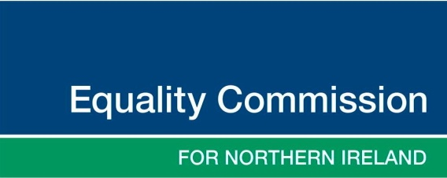  18th January 2022 | Research and Investigations  Equality House  7 - 9 Shaftesbury Square  BELFAST  BT2 7DP  028 90 500 600  www.equalityni.org  InvestigationsTeam@equalityni.org

Measuring Equality in Northern Ireland
– A Monitoring Framework

Stakeholder Consultation

Dear data holder, producer Consultee
The Equality Commission is developing a formal measurement framework for the comprehensive monitoring of equality in Northern Ireland.
This framework will enable the Commission to identify emerging inequalities and track improvements over time, in relation to persistent and deep-rooted inequalities on the lives of people in Northern Ireland. The Commission plans to periodically produce a succinct Statement from the framework, covering particular outcome areas.
The Commission has now got to the stage in its development of this framework where we would like to consult with our stakeholders to hear their views about the draft framework. The draft framework can be accessed online. The document is a table in Word format, so if you need a more accessible version of it for a screen reader, it is also available in an alternative format.
The draft Framework is a work in progress and we have identified six broad areas of life in Northern Ireland to be covered, with nine equality outcome areas described. Each of those outcome areas has associated specific priority areas with potential population indicators and sources of evidence. We will use these sources of evidence to track and measure change over time. We shall present these in our planned Statements – an illustrative example is available online.
The sources of evidence will be our measures and these are drawn from current and available data sources, some of which your organisation may be the data holder/owner. Also, we have gaps in our measures; there are a number of priority areas which we have identified where there appear to be no current sources of evidence, or where data development may be needed.
As either a data producer or user, or if you are interested in the promotion of equality, we seek your specific views to assist us in developing this framework. We would like to consult and hear your opinions and recommendations with regards to the priority areas and the sources of evidence proposed.
The contributions and recommendations gathered from our stakeholders, data users and producers, will be considered and the Commission will finalise its Framework, with outcome areas and associated priorities areas being best measured by the population indicators and sources of evidence identified through the development and consultation process.
Your contribution as a data holder and/or as a data user will also help us identify whether there are other population indicators, and whether there are other regular and robust sources of evidence that are available to us now or in the future.
You can respond to the consultation by completing our online form about the draft framework.
We are also holding consultation focus groups on Thursday 24 and Friday 25 of March. Further details are available on our Eventbrite registration page.
The consultation exercise will close on Friday, 8 April 2022.
If you have any queries about the draft Framework for Measuring Equality in Northern Ireland, please do not hesitate to contact Alexandra De La Torre (ADeLaTorre@equalityni.org).
We look forward to your contribution to this consultation.

Yours sincerely
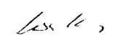
LISA KING
Director of Research and Investigations

 E-mail: InvestigationsTeam@equalityni.org

