

ARTICLE 55 REVIEW

REPORT STRUCTURE

For Small Organisations

(Appendices updated 2014)

ORGANISATION NAME:

REGISTRATION NUMBER:

CONTENTS
 | Page
WHAT IS AN ARTICLE 55 REVIEW | 3
A. THE ORGANISATION | 7
B. ANALYSIS OF COMPOSITION OF WORKFORCE | 8
- Overall workforce
- Main job groups
C. REVIEW OF WORKFORCE FLOWS | 12
- Recruitment and selection
- Promotions
- Leavers
D. REVIEW OF EMPLOYMENT POLICIES, PRACTICES  AND PROCEDURES | 20
- Recruitment and promotion procedures
- Leavers and redundancy
- Transfers
- Training
E. EQUALITY OF OPPORTUNITY | 31
F. ASSESSMENT OF FAIR PARTICIPATION | 35
G. AFFIRMATIVE ACTION | 38
H. GOALS AND TIMETABLES | 43
YOUR VIEWS COUNT | 45
APPENDIX 1 Making an assessment of fair participation
APPENDIX 2 Labour availability
APPENDIX 3 Affirmative action and goals and timetables

What is an Article 55 Review?

Under Article 55 of the Fair Employment and Treatment (NI) Order 1998 all registered concerns are required to complete at least once every three years a review of their employment composition and practices. The purpose of the review is to let you as an employer determine whether or not you need to take action to ensure that Protestants and Roman Catholics are enjoying and are likely to continue to enjoy fair participation in employment in your concern. You are required by law to have regard to the Fair Employment Code of Practice when carrying out your Article 55 Review. The Code includes detailed guidance on Article 55 Reviews at Section 6.3.

This report structure, which takes account of the guidance in the Fair Employment Code of Practice, has been prepared to assist you in completing the formal report of your Article 55 Review. It includes a number of sections to assist you to review your employment pattern, trends and practices and to reach your own conclusions on fair participation, affirmative action and goals and timetables. These form the core components of your Article 55 Review.

THIS REPORT, IF FULLY AND ACCURATELY COMPLETED, WILL BE ACCEPTED BY THE EQUALITY COMMISSION AS A FORMAL ARTICLE 55 REVIEW REPORT.

When should the Article 55 Review report be returned to the Equality Commission?

Unlike your annual monitoring return there is no requirement to submit your Article 55 Review report to the Equality Commission by a specific date. The Equality Commission has a duty to ensure that employers comply with their legal obligation to carry out Article 55 Reviews and in pursuance of this duty you may be requested to submit your Review report to the Equality Commission. It is therefore very important that you complete your Review within the required period and that it is made available on request to the Equality Commission.

YOU SHOULD NOT SUBMIT YOUR COMPLETED ARTICLE 55 REVIEW REPORT TO THE EQUALITY COMMISSION UNTIL REQUESTED TO DO SO.
IF YOUR REVIEW IS REQUESTED BY THE COMMISSION PLEASE PROVIDE A HARD COPY.

What dates/period must the Article 55 Review cover?

As with your annual monitoring returns to the Equality Commission, the dates/period covered by your Article 55 Review relate to the date you first registered with the Equality Commission. This is known as your registration date.

Article 55 Review completion date
Your first Article 55 Review must be completed not later than the third anniversary of your registration date. Subsequent Reviews must be carried out at intervals of not more than three years after the previous Review.

Period to be covered
To give yourself the necessary time to complete a comprehensive Review, you should not wait until the completion date to begin work for the Review.

The beginning and end of the period to be covered by the Article 55 Review should:
- coincide with dates of annual monitoring returns to the Equality Commission
- for a first Review, the beginning of the period should be your date of registration and the end of the period should be two years later.
- for a second, third or subsequent Review, the beginning of the period should be the end date of the last Review and the end should be three years later.

Example 1 Registration date: Feb 1990

4th Review 5th Review 6th Review 7th Review
Article 55 Review period
Start date Feb 1998 Feb 2001 Feb 2004 Feb 2007
End date Feb 2001 Feb 2004 Feb 2007 Feb 2010
Completion date Feb 2002 Feb 2005 Feb 2008 Feb 2011

Example 2 Registration date: May 2001

1st Review 2nd Review
Article 55 Review period
Start date May 2001 May 2003
End date May 2003 May 2006
Completion date May 2004 May 2007

What detail is required in the Article 55 Review report?

This report structure is provided for guidance and should not be viewed as prescriptive. As it is not possible to prepare a report structure which matches the circumstances in all concerns you may wish to amend it to suit your own organisation. However, it is important that all of the main elements as outlined in the “Contents Section” are covered.

Some small concerns may not need to complete such a detailed analysis. For larger complex organisations with more than one location, amendments to the structure of the report may be necessary. If you would like to provide additional information simply insert extra pages or include as an appendix (e.g. Equal Opportunities Policy, Copies of Job Documentation etc.)

Can I expand the scope of the Article 55 Review?

Some employers may be interested in expanding the scope of their tri-annual Review to include a review of employment practices, patterns and trends across other equality categories such as gender, race and/or disability. This is not a statutory requirement.

Such a review is different from the Article 55 Review, in that under Article 55 of the Fair Employment and Treatment (NI) Order 1998 registered employers are required by law to carry out such a review, however any review of the workforce focusing on other categories, is purely voluntary.

Fair employment legislation requires employers to collect monitoring information on community background and on gender. This information forms the basis for the review under Article 55 of employment patterns and trends. This means that your organisation will already have information on the gender composition of the workforce. An analysis of this information would include considerations as to whether, for example there are particular job groups that are more likely to be filled by men or women, or whether part time employees are concentrated in particular job-groups. Based on these considerations you may then determine whether there are any positive action measures that would be appropriate.

While it is not a legal requirement to monitor your workforce by race or disability, the relevant Codes of Practice recommend that you should do so. If you do not monitor on grounds other than community background and gender you can contact the Equality Commission for advice on doing so.

If you wish to broaden the scope of your review to include employment practices more generally or patterns and trends across the categories monitored by your organisation, the Equality Commission can offer you advice, assistance or feedback.

How can I get advice or assistance on completing my Article 55 Review report?

Advice on conducting an Article 55 Review is contained in:

- Section 6.3 of the Fair Employment Code of Practice. Remember that the law requires you to take this guidance into account when completing your review.

- Equality Commission advisory booklet “Article 55 Review: A Guide for Employers”.

Copies of these publications can be obtained free of charge from the Equality Commission.

Equality Commission staff are also available to provide free and confidential advice and assistance. This includes one-to-one advice and a programme of training seminars.

Employment Development
Equality Commission for Northern Ireland
Equality House
7 – 9 Shaftesbury Square
Belfast
BT2 7DP

Tel: (028) 90 500600
Fax: (028) 90 238039
Textphone: (028) 90 500589

REMEMBER!

IF YOU ARE UNSURE ABOUT WHAT YOU SHOULD INCLUDE IN YOUR REVIEW REPORT, THE DATES/PERIOD TO BE COVERED OR ANY OTHER ISSUE, PLEASE CONTACT THE EQUALITY COMMISSION FOR HELP

The Equality Commission also provides a range of publications on all areas of discrimination law and equality for which we have responsibility – religious belief and political opinion; sex discrimination and equal pay; race; disability; sexual orientation; and the statutory duties on public authorities.

A. THE ORGANISATION

1. ORGANISATION NAME:

REGISTRATION NUMBER:

2. Briefly outline any relevant background information e.g. ownership, nature of business, locations, trade unions (where applicable).

3. Period covered by this Review (please insert years)
from |  | to

 |  | Yes | No
4. | Did you seek advice from the Equality Commission concerning the completion of any previous review(s)?
 | Was any previous review(s) submitted to the Equality Commission?
 | Did you have follow up discussions with the Equality Commission following completion of any previous review(s)?
 | If you have answered Yes, to any of these questions please comment providing relevant dates

B. ANALYSIS OF COMPOSITION OF WORKFORCE

This section has been designed to assist you to put together the information needed to review employment patterns and trends during the review period.

The information recorded in the tables should relate to the period covered by this review

REMEMBER!

- For a first review the review period runs from the date of registration until TWO years later

- For a second, third or subsequent review the review period runs from the end of the last review until THREE years later

IF YOU ARE IN ANY DOUBT CONTACT THE

EQUALITY COMMISSION FOR HELP

16 hours or more

In Table 1 enter the composition of your organisation’s workforce who normally worked 16 or more hours per week during this review period.

Table 1: | Composition of the workforce who normally worked 16 or more hours per
 | week in the period from |  | to
(insert start date and end date of review period)

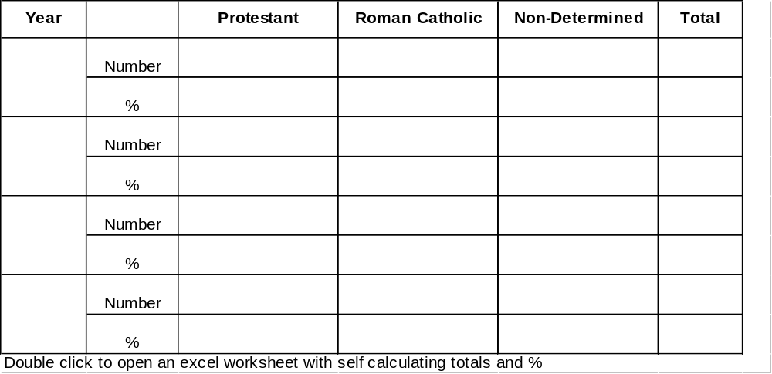

Less than 16 hours

In Table 2 enter the composition of your organisation’s workforce who normally worked less than 16 hours per week from 2001, during the review period (from 2001 onwards you will have included this information under Part-Time (P/T) in your annual monitoring return).

Table 2: | Composition of workforce who normally worked less than 16 hours per week during the review period

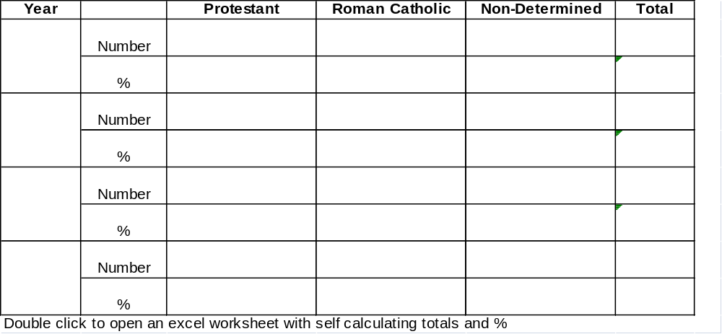
Total Employees

In Table 3 enter the composition of all male and female employees (including those working 16+ hours and less than 16 hours) at the end of this review period

Table 3: | Composition of total workforce by sex in
 |  |  | (insert end date of review period)

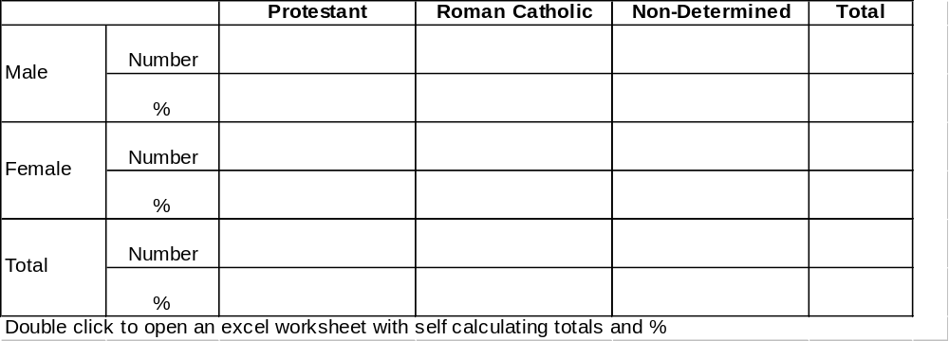

In Table 4 please enter the composition in each of your main job groups at the beginning and end of the review period (as for Table 1) of employees who normally worked 16 hours or more. Please insert appropriate dates in year column.

16 hours or more

Table 4: | Composition by job group of employees who normally work 16 hours or
 | more per week from |  | to
(insert start date and end date of review period)

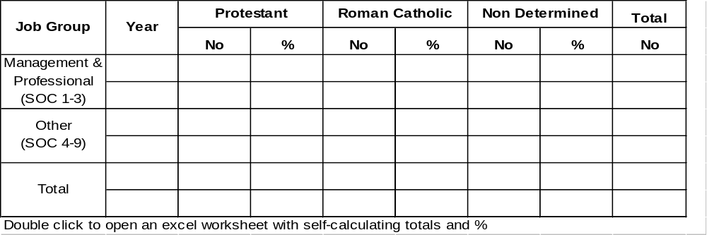* Please insert start date of this review period e.g. 1998
** Please insert end date of this review period e.g. if the start date was 1998, the end date would be 2001

Less than 16 hours

In Table 5 enter the composition in each of the main job groups of employees who normally worked less than 16 hours per week.

Table 5 Composition of Job group of employees who normally worked less than 16 hours per week.

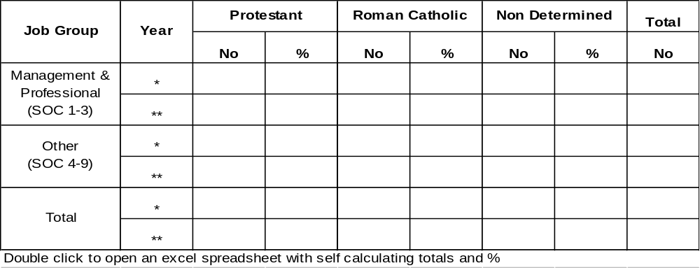* Please insert start date of this review period e.g. 1998
** Please insert end date of this review period e.g. if the start date was 1998, the end date would be 2001
Review of employment patterns and trends

1. | On the basis of the information in Tables 1-5, since the last review(s) has there been any change in:
 |  | Yes | No
 | - the overall number of employees
 | - the Protestant and Roman Catholic proportions
 | - the employment pattern among men and women
 | - the overall numbers employed in any of the main job groups
 | - the Protestant and Roman Catholic proportions in any of the main job groups
2. | Is there any evidence that Protestants or Roman Catholics are well represented in one job group but not in another?

Please comment:

4. Please comment on the representation of both communities and on any changes or trends in the overall employment pattern and in the job groups since the time of the last review taking account of:

- any organisational change (e.g. restructuring, relocation);

- extent of recruitment or redundancies since the last review;

- the effects of any affirmative action taken, or changes to employment practices and procedures you may have made.

Please comment:

C. REVIEW OF WORKFORCE FLOWS

Recruitment and selection

The aim here is to analyse the pattern and trends of applicants for employment and their success in obtaining posts.
The dates to be entered in tables should relate to the period covered by this Review

IF YOU ARE IN ANY DOUBT CONTACT THE EQUALITY COMMISSION FOR HELP

In Table 6 list all recruitment exercises to fill posts which were publicly advertised during the review period. You may need to use continuation tables. Alternatively, if you have collected this information in another way e.g. on computer or by maintaining a recruitment register of individual exercises, you may include a computer printout or the register as an appendix to this report.

Table 6: Individual recruitment exercises (publicly advertised) during the review period

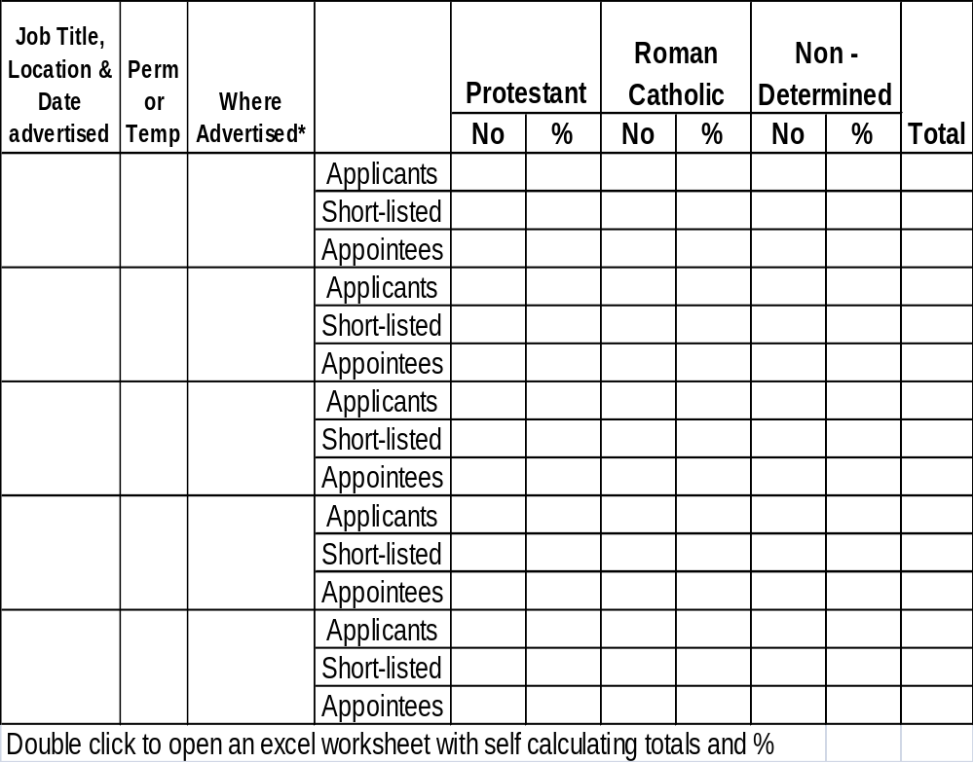

In Table 7 enter the overall numbers and percentages for each of the job groups. You will have to collate information from Table 6 to do this. Each year should correspond to a monitoring year with the first year beginning on the start date of the review period.

For example:
If the review period is 1998 –2001 YEAR 1 is 1998/99
YEAR 2 is 1999/2000 and
YEAR 3 is 2000/2001

Table 7: | Overall recruitment in job groups in the period from |  | to
(Insert the start and end dates of the review period)
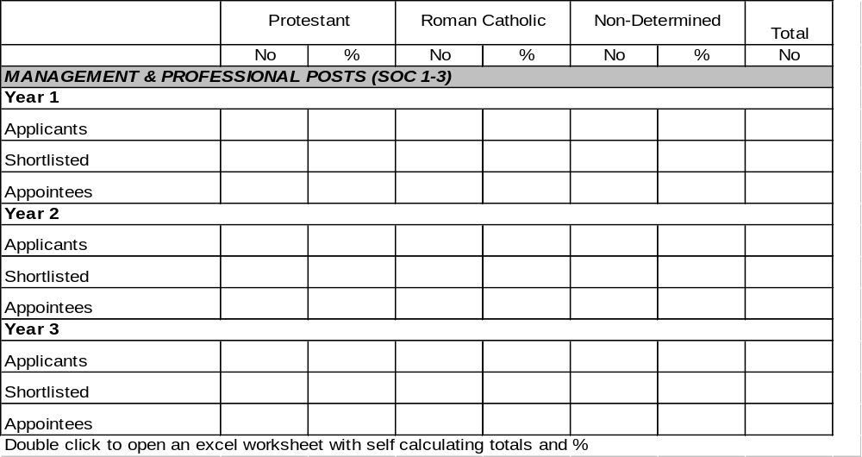
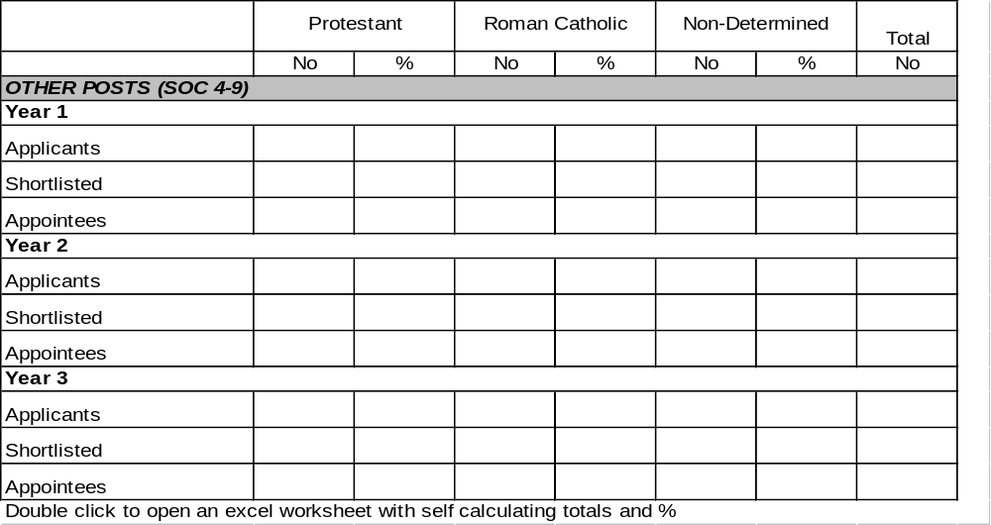

Success Rates

Using the information collected in Tables 6 and 7 you should now calculate and enter in Table 8 the overall success rates for Protestants and Roman Catholics for each job group over the three years of the review period.

The success rate is the number of appointees expressed as a percentage of applicants.

For example: In the management group in Year 1 there were 100 Protestant and 50 Roman Catholic applicants and there were 10 Protestant and 10 Roman Catholic appointees.

the Protestant success rate = 10 = 0.1 = 10%
100
the Roman Catholic success rate = 10 = 0.2 = 20%
50

Table 8: Overall success rates in job groups
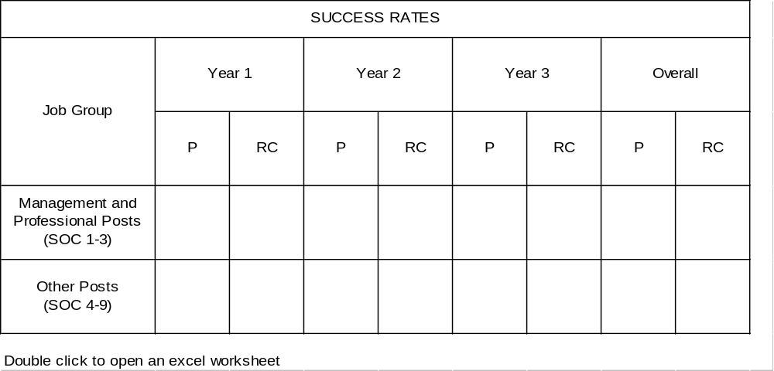

Patterns and trends – individual exercises

You should examine closely the details of individual recruitment exercises in Table 6 before completing the following questions.

1. | Are there any particular exercises:
 |  | Yes | No
which attracted a low number of applicants from the Protestant community?

which attracted a low number of applicants from the Roman Catholic community?

2. | Is there any difference in the pattern of applicants for permanent and temporary posts?
3. | Are you aware of any differences in the pattern for full-time and part-time posts?
4. | Are there any individual exercises where one community appears  to have fared less well at any stage of selection?
 | Management & Professional
 | Other Posts

If you have answered Yes to any of the above questions, please comment:

If you find any exercises like this, you should review the recruitment file and records paying particular attention to the procedures and criteria which were used. If there is any evidence that procedures were not followed or that selection criteria adversely affected one community you will need to take remedial action.

Patterns, trends and success rates in job groups

You should examine closely the details of the overall pattern of recruitment and success rates in the various job groups (Tables 7 and 8) before completing the following.

5. | Is there any evidence of change in the proportion of applicants from each community since the time of the last review?
 |  | Yes | No
 | Management & Professional
 | Other Posts
6. | Is there any evidence that either community has been less successful in obtaining posts in any of the job groups?
 |  | Yes | No
 | Management & Professional
 | Other Posts

If you have answered Yes to any of the above questions, please comment:

If you find any evidence that either Protestants or Roman Catholics have been less successful in obtaining posts in any job group you should conduct a more detailed analysis. You should seek advice from the Equality Commission on this.

Promotions

You should consider as promotions those posts which were filled internally without any external advertisement. Promotions would therefore include:

- those promoted through internal competition
- those promoted in other ways such as regrading, staff appraisal or management decision.

In Table 9, list details of all promotions since the time of the last review. You may need to use a continuation table or amend the table as required.

Table 9: | Composition of all promotees during the period from |  | to
(insert start and end dates of review period)

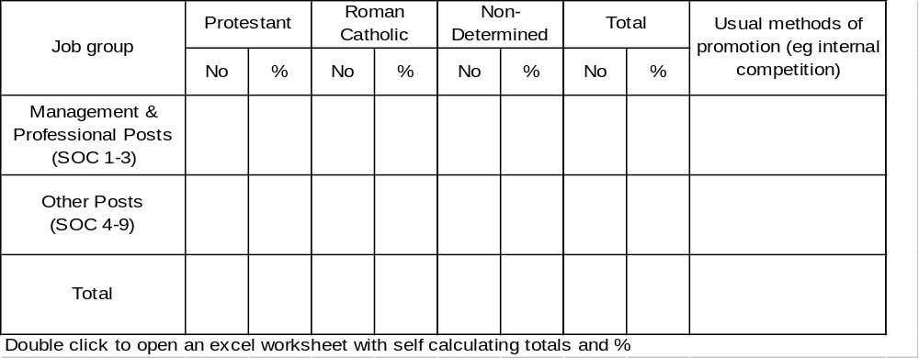

 |  | Yes | No
7. | On the basis of the information in Table 9 is there any evidence that one community is less successful than the other in obtaining promotions?
8. | Are there any differences in the composition of those promoted for any job group?
 | Management & Professional
 | Other Posts
9. | Is there any evidence that one community is more likely to be promoted by any particular method than another?

If you have answered Yes to any of these questions please comment:

If you find any evidence that either Protestants or Roman Catholics have been less successful in obtaining promotion, you should conduct a more detailed analysis.

Leavers

In Table 10 enter the composition of those who have left the organisation’s employment since the time of the last review.

Table 10: | Leavers and reasons for leaving from |  | to
(insert start and end dates of review period)

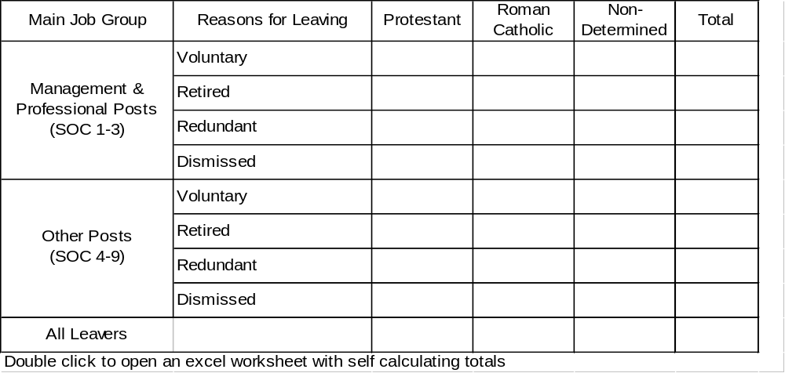

Please rank the reasons for people leaving the organisation’s employment in numerical order. (e.g. the most common reason should be ranked as 1, the next most common as 2 etc.)

Voluntary |  |  | Redundant
Retired |  |  | Dismissed
Contract Expired |  |  | Other
 |  |  |  |  | Yes | No
10. | Is there any evidence that one community is more likely to leave than another

If Yes, please comment:

D. EMPLOYMENT POLICIES, PRACTICES & PROCEDURES

This section has been designed to assist you to review policies, practices and procedures which have an impact on equality. The purpose of this review is not simply to record what your employment policies, practices and procedures are but rather to enable you to identify where action for change may be necessary. At the end of each section there is space for you to summarise your findings and any action points identified as a result of this review.

Recruitment and promotion procedures

To fully complete this part of your review you will need to:

- review your recruitment and promotion policies, procedures and practices to ensure that they comply with the recommendations included in Section 5.3 of the Fair Employment Code of Practice and;

- examine a sample of recruitment and promotion files to assess how your procedures have been implemented

- examine the criteria used in selection for recruitment, promotion, training and redundancy to ensure that they are strictly job related, appropriate in every case and do not have an adverse impact on either community.

The following questions have been designed to take you through the main stages in the recruitment and selection process and to focus on equality issues. They should not be seen as prescriptive - you may wish to look more closely at other aspects of your procedures.

You should consult Section 5.3 of the Fair Employment Code of Practice before completing the following.

Job documentation
 |  | Recruitment |  |  |  | Internal Promotions
 |  | Always | Sometimes | Never |  | Always | Sometimes | Never
1. | Have job descriptions been prepared?
2. | Have personnel specifications been prepared?
3. | Do you use standard application forms?

Advertising
 |  | Recruitment |  |  | Promotion
 |  | Yes | No |  |  | Yes | No
4. | When recruiting, does your organisation advertise all vacancies for employment widely, ensuring members of both communities are aware of them? (e.g. via press, T&EA, others etc)
5. | Are informal methods (e.g. ‘word of mouth’) ever used as a main or sole source of applicants?
6. | Have you used any procedures by which applicants are mainly or wholly identified through restricted groups? (paragraph 5.3.5 of Code of Practice)
 | If Yes, has this resulted in a disproportionately high number of one community coming forward?

7. | Do you use an Equal Opportunity Statement in job advertisements?
 |  | Always | Sometimes | Never
 | Recruitment
 | Promotion

What statement(s) do you generally use?

Recruitment

Promotion

8. | Has a statement specifically encouraging applicants from any under-represented community been included in any job advertisements?
 |  | Always | Sometimes | Never
 | Recruitment
 | Promotion

What statement(s) do you generally use?

Recruitment

Promotion

9. | Which of the following are used when advertising positions?
 |  | Province wide papers | local  papers | T&EA | other agencies
 | Management & Professional
 | Other
 |  |  |  | Yes | No
10. | Having examined the applicant information in your review of workforce flows are you satisfied that your existing practice is encouraging the widest possible field of applicants?

Shortlisting/Interviewing panels
 |  | Recruitment |  |  |  | Promotions
 |  | Always | Sometimes | Never |  | Always | Sometimes | Never
11. | Do you ensure that selection panels are comprised of two or more people?
12. | Do you ensure that where practicable there is cross community representation on selection panels?
13. | Do you ensure that the same panel is used at shortlisting and interview?

14. | Are all members of selection panels provided with training/guidance on:
 |  |  |  |  | Yes |  | No
 | - selection methods?
 | - the Fair Employment legislation and its implications?
 | - the Fair Employment Code of Practice?
 | - the Company’s Equal Opportunity Policy?
15. | Do members of selection panels meet formally before shortlisting and interview to decide:
 |  | Recruitment |  |  | Promotion
 |  | Yes | No |  | Yes | No
 | - on relevant and appropriate criteria (e.g. qualifications, experience etc) to be used in the selection process?
 | - on the importance to be given to each factor at each stage of selection?
16. | Do interview panels meet formally to agree the structure and conduct of interviews?
17. | Are marking systems used at interview?
18. | Do these reflect the criteria for the job?
19. | Are weightings used to rank the importance of the various criteria?
20. | Can these weightings be justified?

Shortlisting Records

21. | Have the following formal records been retained:

 |  | Recruitment |  |  |  | Promotions
 |  | Always | Sometimes | Never |  | Always | Sometimes | Never
 | - Job description
 | - Personnel specification
 | - Application forms
 | - Notes of panel meetings
 | - Shortlisting criteria
 | - Reason for selection or rejection of individual applicants

Interview Records

22. | Have the following formal records been retained:
 |  | Recruitment |  |  |  |  | Promotions
 |  | Always | Sometimes | Never |  | Always |  | Sometimes | Never
 | - Notes of panel meetings
 | - Interview questions
 | - Individual interviewer’s assessments
 | - Panel decision

Selection Criteria

To complete this part of the review you will need to :

- examine job documentation and records maintained of the selection process and
- examine the information in your review of workforce flows on the composition of those shortlisted and appointed
23. | Are you satisfied that selection criteria are:
 |  | Recruitment |  |  | Promotion
 |  | Yes | No |  | Yes | No
 | - strictly job-related
 | - appropriate in every case
 | - not having an adverse impact on either community
Selection Tests
 |  |  |  |  | Yes | No
24. | Are tests used for any recruitment exercises?
25. | Are you satisfied that all tests used are:
 | - appropriate to the job
 | - do not adversely impact on either community
 | - marked in a fair and consistent manner
 | - supervised by staff trained in their use
Summary

Please consider all your answers to the above questions and comment below including any action points arising from this review. Remember you will have to take action if you find that:

- procedures are not in line with the Fair Employment Code of Practice or
- procedures have not been consistently followed or
- selection criteria are not appropriate or having an adverse impact on either community

Leavers and redundancy
 |  |  |  | Yes | No
26. | Do you monitor the composition of those who leave the organisation’s employment?
27. | Is there any evidence from the information on leavers that a disproportionately high number of either community have left for any reason?
 |  | Always | Sometimes |  | Never
28. | Do you conduct exit interviews for leavers?
 |  |  |  | Yes | No
29. | Are leavers’ views on the provision of equal opportunities within the organisation requested on exit interview forms?
30. | Have any equal opportunities issues been identified as a result of exit interviews?
If Yes, has any follow up action been taken?
Please comment:

 |  |  |  | Yes | No
31. | Does the organisation have a formal written redundancy procedure?
If No, do you have any plans to introduce a formal redundancy procedure?
Please comment:

32. | Are you satisfied that your selection criteria for redundancy:
 |  |  | Yes | No
 | - are appropriate?
 | - do not adversely impact on either community?
33. | Is length of service included as a selection criterion for redundancy?
 | If Yes, have you reviewed the use of length of service to assess if this adversely impacts on either community?
 | If Yes, is there any evidence of adverse impact?
 |  | Yes | No | N/A
34. | Have you considered how the use of length of service in selection for redundancy might impact on any affirmative action measures you may be taking?
35. | Have you any plans to review the use of length of service as a selection criterion for redundancy?

Please review the information on leavers and redundancy and comment below including any action points arising from this review. In particular you should take action where you find that there is a disproportionate number of one community leaving the organisation for any reason or the selection criteria for redundancy are not appropriate or adversely impact on either community.

Transfers
36. | Does the organisation have:
 |  |  | Yes | No
 | - a written transfer policy?
 | - a written transfer procedure?
37. | Having examined the information on transfers, are you satisfied that:
 | - all staff are made fully aware of transfer opportunities
 | - equal access is afforded to each community
Training

Training for employees
38. | Does the organisation have:
 | - a written training and development policy?
 | - a written training and development procedure?
39. | Are you satisfied that all staff have been made fully aware of training and development opportunities?
40. | Is there any evidence that one community is not availing of training opportunities?
41. | Do you plan to review your staff training and development policy/procedure?

Training for persons not employed by the company
 |  | Yes | No
42. | Has the organisation participated in any Government training initiatives for groups not already employed in the workforce?
43. | Having examined the information on training are you satisfied that:
 | - training opportunities are advertised widely and suitably eligible and qualified persons are made aware and encouraged to apply
 | - opportunities are not limited or confined to one community
 | - formal systematic and objective methods are in place for selecting those to avail of training opportunities
44. | Do you have a formal written policy relating to training opportunities provided by the Company?
45. | Do you have a formal written procedure relating to training opportunities provided by the Company?
46. | Do you plan to review your policy/procedures for selection for this type of training?

Please review the information on transfers and training and comment below including any action points arising from this review.

E. EQUALITY OF OPPORTUNITY

Consideration of equal opportunities within the organisation
 |  | Yes | No | N/A
1. | Does your organisation have a written policy on equality of opportunity in Northern Ireland?
2. | Has overall responsibility for equal opportunities been allocated to a senior member of staff within the organisation?
3. | Is this stated in the Policy?
4. | Was the report of the organisation’s last review formally considered:
 | - at a senior level?
 | - by the Board of Directors?
5. | How often have equal opportunities issues been formally considered at a senior level since the time of the last review?:
 | - Twice Yearly
 | - More Often (Please Specify)
 | - Less Often (Please Specify)
 |  | Yes | No
6. | Has the workforce been made aware of the organisation’s Equal Opportunities Policy?
 | Please comment:

 |  | Yes |  | No
7. | Are there recognised trade unions in the organisation?
 | If Yes, which trade unions are recognised in the organisation?
 |  | Yes |  | No |  | N/A
8. | Have the findings of the last review been discussed with the trade unions / employee representatives?
9. | Has there been any consultation with trade unions / employee representatives concerning this review?
10. | Has there been any consultation with trade unions / employee representatives on any other equal opportunities issues?
 | Please comment:
Action to ensure a harmonious working environment
 |  |  | Yes |  | No | N/A
11. | Has the organisation sought to agree a Joint Declaration of Protection with the trade unions?
12. | Has a Joint Declaration of Protection been agreed?
 |  |  | Yes |  | No
13. | Does the organisation have a written statement of policy on a harmonious working environment?
 | If Yes, is this included in the Equal Opportunities Policy?
14. | Does the organisation have a policy statement on harassment? (distinct from the Equal Opportunities Policy)
15. | Does the organisation have a specific procedure for dealing with harassment?

 |  | Yes | No
16. | Does the organisation’s Equal Opportunities Policy make it clear that:
 | - discrimination is a disciplinary offence
 | - harassment is a disciplinary offence?
17. | Has the workforce been made aware of the organisation’s policy on a harmonious working environment?
18. | Has the workforce been made aware of the organisation’s policies and procedures on harassment?

Equal opportunities training
 |  | Yes | No
19. | Has the organisation provided any specific equal opportunities training?
 | If Yes, please indicate by ticking the appropriate box(es) in Table 11.

Table 11: Equal opportunities training carried out during the review period

 | Good practice in recruitment & selection | Training to overcome sectarian harassment | * Equality awareness | Other (please specify)
Managers
Supervisory
staff
Employees
Trade union representatives
* Communication/implementation of the organisation’s affirmative action plan

20. | Was training conducted by:
 |  | Yes | No
 | - the organisation?
 | - consultants?
 | - Equality Commission?
 | - other?
 | If Other (please specify)
Complaints of discrimination or harassment
 |  | Yes |  | No
21. | During the review period have any complaints of discrimination or harassment been raised either through?
 | internal procedures?
 | the Fair Employment Tribunal?
 | If Yes, what was the outcome?

 |  | Yes | No
22. | Has any action been taken following the conclusion of these complaints?
 | If you have answered Yes to the above question please comment:
 | Please consider the information collected in this section and comment below including any action points arising from this review.

F. ASSESSMENT OF FAIR PARTICIPATION

The aim of this section is to allow you to assess if you need to take action in order to secure or maintain fair participation of Protestants and Roman Catholics in your organisation. This is the primary purpose of your review and it must be clearly addressed.

Article 55(1) of the Fair Employment and Treatment (NI) Order 1998 makes it clear that employers’ reviews are “for the purposes of determining whether members of each community are enjoying, and are likely to continue to enjoy, fair participation in employment in the concern”

This section has been designed to assist you to assess the situation concerning fair participation of both Protestants and Roman Catholics in employment in your concern. Table 12 is only a guide and should be amended or added to where appropriate, to reflect the structure of your organisation. For example this may be necessary where you employ a significant proportion of employees who normally work less than 16 hours per week or where you have employees at a number of different locations.

The assessment of fair participation should include for each job group:

- an outline of what you consider to be the relevant catchment area;
- what you consider to be the appropriate comparator (Appendix 2 includes information on labour availability)
- a comparison of those employed with the appropriate comparator
- a comparison of applicant/appointee information with the appropriate comparator
- your conclusion on whether or not further action is needed to secure or maintain fair participation.

A further step by step guide to assist you in making an assessment of fair participation has been included in Appendix 1. This includes detailed guidance on defining catchment areas and the availability of both communities in these catchment areas.

IF YOU ARE IN ANY DOUBT ABOUT HOW TO COMPLETE THIS SECTION YOU SHOULD CONSULT THE EQUALITY COMMISSION FOR ADVICE
Please complete Tables 12 and 13 taking account of the guidance in Appendix 1

Table 12: Catchment areas and comparators - using year 3 information and excluding non-determined
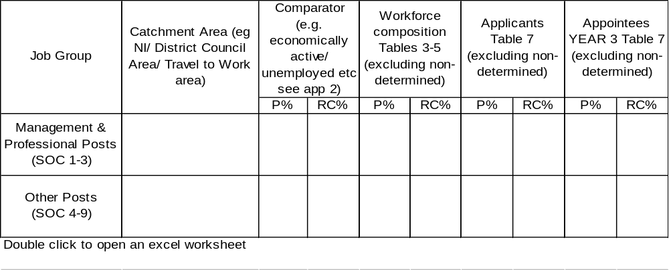

Table 13: Assessment of fair participation

Taking account of the information collected in Table 12 complete the following for each job group by ticking one appropriate box in each case.

Job Group | Workforce in line with comparator |  | Applicants in line with comparator
Job Group | Yes | No | Yes | No
MANAGEMENT
& PROFESSIONAL POSTS
OTHER POSTS

On the basis of these figures and any other information you may have, can you identify any areas of under-representation with regard to applicants for employment or the composition of your present workforce for either Managerial and Professional Posts or Other Posts?

NB: The Commission recognises that for small organisations this cannot be an exact science and it needs to be borne in mind that since the number of employees in your workforce may be small, a difference in one or two people can lead to a large difference in proportions.

Workforce
1. | Have you concluded for any job group in your workforce that:
 |  | Yes | No
 | - Protestant representation is lower than would be expected?
 | - Roman Catholic representation is lower than would be expected?
 | - representation of both communities is in line with what would be expected?

Applicants for employment
2. | Have you concluded for applicants for any job group that:
 |  | Yes | No
 | Protestant representation is lower than would be expected?
 | Roman Catholic representation is lower than would be expected?
 | representation of both communities is in line with what would be expected?
 | If you have identified any areas of under-representation, either among those employed or applicants for employment, please identify the relevant job-group(s) and the community under-represented.
3. | Have you concluded for any job groups that:
 |  | Yes | No
 | - further action is needed to secure fair participation?
 | - further action is needed to ensure fair participation is maintained?
 | Please comment below

G. AFFIRMATIVE ACTION

In this section you should identify any affirmative action measures which you propose to take as a result of this Review.

Remember if you have identified any under-representation of either community you must determine appropriate affirmative action to remedy the situation.

While the Equality Commission encourages employers to develop affirmative action which best fits their own organisations there are some key areas in which it is common to identify affirmative action measures.

Further guidance on affirmative action can be found in:

- Appendix 3
- The Fair Employment Code of Practice and
- The Equality Commission publication ‘Taking Affirmative Action: A Guide for Employers’

Please complete the following indicating any affirmative action measures which you have already taken or you intend to take as a result of this Review.

AFFIRMATIVE ACTION MEASURES | Already Taken | Planned | Not  Planned | Not  Applicable

Equal Opportunities Policies and Procedures
Amend equal opportunities policies

Allocate overall responsibility for equal opportunities issues to a senior member of management

Introduce training on equal opportunities policies/ procedures for:

- managers / supervisors

- the workforce

Consult with trade union/employee representatives about your equal opportunities policies and procedures

AFFIRMATIVE ACTION MEASURES | Already Taken | Planned | Not  Planned | Not  Applicable
The Working Environment
Review disciplinary procedures to ensure that discrimination and harassment are covered

Develop a separate policy and procedure on harassment

Seek to agree a Joint Declaration of Protection with trade unions

Employment Practices
Amend/formalise practices and procedures for:

- recruitment

- promotion

mend selection criteria related to employment / experience for:

- recruitment

- promotion

Review seniority practices in relation to promotion

End the use of internal methods as the sole means of promotion by publicly advertising all vacancies

Introduce training on equal opportunities issues for those involved in:

- recruitment

- promotion

AFFIRMATIVE ACTION MEASURES | Already Taken | Planned | Not  Planned | Not  Applicable
Introduce cross community representation on selection panels

Introduce:

- monitoring of leavers

- exit interviews for all leavers

Amend/develop a formal redundancy procedure

Review the use of length of service as a selection criterion for redundancy

Amend/introduce formal policies and procedures for:

- training of employees

- transfer of employees

Introduce monitoring of:

- training of employees

- transfer of employees

Outreach Measures

Action specifically targeted at under-represented groups
Placing advertisements in newspapers read by the under-represented community

Include a statement in public advertisements specifically welcoming applications from the:

- Protestant community

Include a statement in public advertisements specifically welcoming applications from the:

- Roman Catholic community

AFFIRMATIVE ACTION MEASURES | Already Taken | Planned | Not  Planned | Not  Applicable
Include a statement in internal advertisements/ promotion notices specifically welcoming applications from the:

- Protestant community

- Roman Catholic community

Specifically target schools/community organisations to encourage applications for employment, training or work experience:

- Protestant community targeted

- Roman Catholic community targeted

Hold meetings with influential individuals or organisations to encourage applications for employment, training or work experience within the:

- Protestant community

- Roman Catholic community

Circulate vacancies to job clubs/community organisations to encourage applications from the:

- Protestant community

- Roman Catholic community

Target sponsorship of sports/youth/community events at any under-represented community

AFFIRMATIVE ACTION MEASURES |  |  | Yes |  | No |  | Considering
Encouraging recruitment from those not in employment
Take action to recruit from those not in employment, in accordance with Article 75 of the Fair Employment and Treatment (NI) Order 1998.

If Yes, please give details of action taken:
Religion Specific Training
Undertake religion specific training in accordance with Article 76 of Fair Employment and Treatment (NI) Order 1998.

Affirmative Action Training
Provide affirmative action training under Article 72 of the Fair Employment and Treatment (NI) Order 1998.

Note: | If you have answered Yes or Considering to the above questions on encouraging recruitment from those not in employment, religious specific training or affirmative action training you should contact the Equality Commission for advice or approval, as necessary.
AFFIRMATIVE ACTION MEASURES |  | Already Taken |  | Planned |  | Not  Planned |  | Not  Applicable
Other Action

Please Specify:
H. GOALS AND TIMETABLES
The aim of this section is to enable you to set goals for increasing applications from an under represented group.

Your review may have shown that you need to take affirmative action to achieve a workforce which is more representative of your potential labour market. In such a circumstance you may wish to set yourself a goal of increasing applications for the under-represented community within a period of time.

Such goals and timetables are particularly appropriate in situations where, after comparing your workforce with what might reasonably be expected given your catchment areas, you find that:

There is a very low number of employees from either community background,
This has been the pattern over a long period of time, and
You do not appear to be recruiting a reasonable proportion of applicants from that community

These goals are not ‘quotas’ and cannot be met through the use of ‘reverse’ or any other form of unlawful discrimination. At the point of selection the best person must be appointed irrespective of community background.

Please complete the following to set yourself a goal for increasing applicants from an under-represented group.

This organisation will aim to increase applicants from the Protestant/Roman Catholic* community to _______ % over the next _______ year(s).
* Delete as appropriate

If No, Please state why you do not consider it appropriate to set goals and timetables.

Please add below any further information you would like to include as part of your Article 55 Review.

This report has been completed by:

Signed:

Position:
Date:

YOUR VIEWS COUNT

To assist us in the preparation of future advisory materials, we would welcome
feed-back from employers on the report structure for this review.

Name of organisation:

Was the report structure of practical value? Yes No

How would you rate the various sections of the report structure?
Please tick the appropriate boxes

 | Very Helpful | Helpful | Unhelpful
Analysis of composition of workforce

Review of workforce flows

Review of training

Review of employment policies, practices and procedures

Equality of opportunity

Assessment of fair participation

Affirmative action

Goals and timetables

Which part of the report structure did you find most helpful?
Which part of the report structure did you find least helpful?
What changes would you recommend?
APPENDIX 1

MAKING AN ASSESSMENT OF FAIR PARTICIPATION

STEP 1 - Define catchment areas

The catchment area is the area from which you would reasonably be expected to recruit. You should define a catchment area for each job group.

Generally, the catchment area is closely related to your location and any skills, qualifications or experience required for the job but there are a number of other factors which you should take into account. These are:

- requirements to undertake shift work/unsociable hours or to work at more than one location
- levels of pay and hours worked
- travelling conditions e.g. if public transport is infrequent or non-existent, this may limit some jobs to those in the immediate area
- supply and demand - when jobs are in short supply people may be prepared to travel greater distances
- any information you may have on the residence pattern of applicants - but remember to take account of any “chill” factors
- any other relevant factors

For example: - for a senior management post the catchment area would be Northern Ireland while for a basic manual post the catchment area may be the local district council area or the travel to work area.

STEP 2 - Identify comparators

The comparator is the availability of members of each community within the catchment area. You should identify a suitable comparator for each job group.

For each job group you should consider the composition of:

- the economically active population
- the unemployed
- school leavers/younger populations
- those with the necessary skills and/or qualifications
You should decide on the most appropriate comparator taking into account the nature of the job.

Generally

- for jobs which do not require special skills or experience you should take into account the composition of both the economically active population and the unemployed
- for jobs requiring specific qualifications, skills or experience you should take into account the composition of the younger population and/or those with the required skills.

Appendix 2 includes information on labour availability i.e. the religious composition of those available for work in each District Council Area, Travel to Work Area and in Northern Ireland as a whole.

STEP 3 - Compare composition of workforce and applicants with appropriate comparator to enable you to make an assessment of fair participation.

Compare the composition of the workforce and applicants by job group with the comparators identified at Step 2.

Fair participation will not be present where:

- the composition of the job group is not broadly in line with what you would expect and/or
- either Protestants or Roman Catholics are applying in fewer numbers than might be expected for employment, promotion or training.

If any of these features exist it does not necessarily imply a lack of fair practice, but it does mean that affirmative action may be necessary.

APPENDIX 2

LABOUR AVAILABILITY - ECONOMICALLY ACTIVE AND UNEMPLOYED

The tables in this Appendix present information which you should find useful when assessing the religious breakdown of the workforce in your catchment area. All of the information has been derived from the Summary Report of the Northern Ireland 2011 Population Census. The information is provided at a Northern Ireland level and for District Council and travel to work areas. Travel to work areas are made up from a number of District Council Areas. For example, the Belfast Travel to Work Area is made up of 10 District Council Areas in the Greater Belfast area.

Table A: includes information on the community composition of economically active persons aged 16-74 by District Council Area and travel to work area. The figures for the economically active include those individuals unemployed and actively seeking work.

Table B: provides information on the community composition of unemployed persons for each District Council Area and travel to work area throughout Northern Ireland. For many basic posts many applications will be drawn from those currently unemployed. Employers should therefore have regard to the composition of the unemployed when assessing the proportions of each community you would reasonably expect to obtain for these posts.

Table C: provides information on the community composition of economically active persons aged 16 to 74 by Standard Occupational Classification group.

Table D: provides information on the community composition of economically active persons aged 16 to 74 by the highest level of academic qualification.

Further information on labour availability and how to use it can be obtained from the Equality Commission at Belfast (02890) 500600. Please do not hesitate to contact the Equality Commission for assistance.

TABLE A: Percentages of Protestant, Roman Catholics (Community Background: Religion or Religion brought up in) and those of Other Religions and No Religion for Economically Active Persons aged 16-74 years by District Council Area

Note:
- You should give consideration to which groupings of District Council Areas (DCAs) best approximate the catchment area for the type of employment being considered.
- To assist the reader we have also grouped the DCAs in the table below to approximate the Travel to Work Areas (in capitalised bold) identified from Census 2001 data .
- It should be noted that these groupings are only an approximation as Census 2011 data on Travel to Work Areas is not yet available and DCAs do not correspond directly to Travel to Work Areas (TTWA) - for example, Ballymena TTWA a small portion of Moyle and Ballymoney DCA as well as Ballymena DCA.

 | Protestant and Other  Christian (including  Christian related) |  |  | Catholic  (Roman Catholic) |  |  |  | Other Religion |  |  |  |  |  |  | No Religion |  | Total
 | [%] |  | No. | [%] |  |  | No. |  | (%) |  |  | No. |  |  | (%) | No. | No.
BALLYMENA  Ballymena | [75.2%] | 22,808 |  | [24.8%] |  | 7,511 |  | (0.9%) |  |  | 274 |  |  |  | (4.5%) | 1,427 | 32,020
BELFAST
Antrim | [54.9%] | 13,922 |  | [45.1%] |  | 11,434 |  | (1.0%) |  |  | 284 |  |  |  | (6.3%) | 1,721 | 27,361
Ards | [85.4%] | 29,886 |  | [14.6%] |  | 5,094 |  | (1.0%) |  |  | 397 |  |  |  | (7.8%) | 2,994 | 38,371
Belfast | [45.8%] | 55,164 |  | [54.2%] |  | 65,167 |  | (1.9%) |  |  | 2,501 |  |  |  | (7.4%) | 9,834 | 132,666
Carrickfergus | [88.3%] | 15,662 |  | [11.7%] |  | 2,069 |  | (1.0%) |  |  | 198 |  |  |  | (8.5%) | 1,667 | 19,596
Castlereagh | [72.5%] | 22,456 |  | [27.5%] |  | 8,528 |  | (1.3%) |  |  | 454 |  |  |  | (7.5%) | 2,544 | 33,982
Down | [34.6%] | 11,114 |  | [65.4%] |  | 21,029 |  | (0.6%) |  |  | 197 |  |  |  | (3.9%) | 1,308 | 33,648
Larne | [73.5%] | 11,021 |  | [26.5%] |  | 3,970 |  | (0.6%) |  |  | 96 |  |  |  | (5.5%) | 875 | 15,962
Lisburn | [61.7%] | 33,932 |  | [38.3%] |  | 21,101 |  | (0.9%) |  |  | 555 |  |  |  | (5.9%) | 3,473 | 59,061
Newtownabbey | [72.9%] | 28,676 |  | [27.1%] |  | 10,640 |  | (1.1%) |  |  | 472 |  |  |  | (7.2%) | 3,071 | 42,859
North Down | [82.8%] | 28,772 |  | [17.2%] |  | 5,977 |  | (1.2%) |  |  | 482 |  |  |  | (10.7%) | 4,238 | 39,469
TOTAL | [61.8%] | 250,605 |  | [38.2%] |  | 155,009 |  | (1.3%) |  |  | 5,636 |  |  |  | (7.2%) | 31,725 | 442,975
COLERAINE
Ballymoney | [66.8%] | 9,465 |  | [33.2%] |  | 4,694 |  | (0.6%) |  |  | 91 |  |  |  | (3.3%) | 490 | 14,740
Coleraine | [69.0%] | 18,095 |  | [31.0%] |  | 8,125 |  | (0.9%) |  |  | 252 |  |  |  | (4.8%) | 1,323 | 27,795
Moyle | [38.2%] | 2,906 |  | [61.8%] |  | 4,710 |  | (0.5%) |  |  | 36 |  |  |  | (2.4%) | 185 | 7,837
TOTAL | [63.5%] | 30,466 |  | [36.5%] |  | 17,529 |  | (0.8%) |  |  | 379 |  |  |  | (4.0%) | 1,998 | 50,372
CRAIGAVON
Armagh | [50.7%] | 14,168 |  | [49.3%] |  | 13,769 |  | (0.6%) |  |  | 179 |  |  |  | (2.7%) | 795 | 28,911
Craigavon | [51.3%] | 21,821 |  | [48.7%] |  | 20,717 |  | (0.9%) |  |  | 393 |  |  |  | (4.6%) | 2,078 | 45,009
TOTAL | [51.1%] | 35,989 |  | [48.9%] |  | 34,486 |  | (0.8%) |  |  | 572 |  |  |  | (3.9%) | 2,873 | 73,920
DUNGANNON  Dungannon | [35.2%] | 9,541 |  | [64.8%] |  | 17,574 |  | (0.6%) |  |  | 181 |  |  |  | (2.1%) | 585 | 27,881
ENNISKILLEN
Fermanagh | [39.6%] | 11,499 |  | [60.4%] |  | 17,534 |  | (0.6%) |  |  | 186 |  |  |  | (2.1%) | 633 | 29,852
LONDONDERRY
Derry | [24.6%] | 11,320 |  | [75.4%] |  | 34,776 |  | (0.9%) |  |  | 410 |  |  |  | (2.0%) | 941 | 47,447
Limavady | [39.8%] | 5,855 |  | [60.2%] |  | 8,850 |  | (0.4%) |  |  | 66 |  |  |  | (2.0%) | 296 | 15,067
TOTAL | [28.2%] | 17,175 |  | [71.8%] |  | 43,626 |  | (0.8%) |  |  | 476 |  |  |  | (2.0%) | 1,237 | 62,514
(Table A continued on next page)
Table A (continued)

 | Protestant and Other  Christian (including  Christian related) |  |  | Catholic  (Roman Catholic) |  |  |  | Other Religion |  |  |  | No Religion |  |  | Total
 | [%] |  | No. | [%] |  |  | No. |  | (%) |  | No. | (%) |  | No. | No.
MID-ULSTER
Magherafelt | [32.2%] | 6,767 |  | [67.8%] |  | 14,257 |  | (0.5%) |  | 109 |  | (1.7%) | 372 |  | 21,505
Cookstown | [40.4%] | 6,842 |  | [59.6%] |  | 10,091 |  | (0.5%) |  | 83 |  | (2.3%) | 402 |  | 17,418
TOTAL | [35.9%] | 13,609 |  | [64.1%] |  | 24,348 |  | (0.5%) |  | 192 |  | (2.0%) | 774 |  | 38,923
NEWRY  Newry and Mourne | [19.5%] | 8,761 |  | [80.5%] |  | 36,235 |  | (0.5%) |  | 238 |  | (2.1%) | 973 |  | 46,207
Banbridge | [66.0%] | 15,169 |  | [34.0%] |  | 7,822 |  | (0.6%) |  | 157 |  | (4.3%) | 1,039 |  | 24,187
TOTAL | [35.2%] | 23,930 |  | [64.8%] |  | 44,057 |  | (0.6%) |  | 395 |  | (2.9%) | 2,012 |  | 70,394
OMAGH  Omagh | [28.9%] | 6,706 |  | [71.1%] |  | 16,509 |  | (0.5%) |  | 108 |  | (1.6%) | 370 |  | 23,693
STRABANE  Strabane | [36.2%] | 6,161 |  | [63.8%] |  | 10,854 |  | (0.3%) |  | 59 |  | (0.9%) | 149 |  | 17,223
NORTHERN IRELAND | [52.4%] | 428,489 |  | [47.6%] |  | 389,037 |  | (1.0%) |  | 8,458 |  | (5.0%) | 43,783 |  | 869,767

Notes: 1. Source: Census 2011 (Table DC2626NI)
2. ‘Economically active’ relates to whether or not a person who was aged 16 to 74 was working or looking for work in the week before the Census.
3. ‘Total’ includes all those whose Community Backgrounds were ‘Catholic’ or ‘Protestant and Other Christian’ or ‘Other Religion’ or ‘No Religion’.
4. Square bracket ‘[%’] percentages are a percentage of total Catholics and Protestants only. Round bracket percentages ‘(%’) are a percentage of the overall ‘Total’ of all economically active persons aged 16-74 years.

TABLE B: Percentages of Protestant, Roman Catholics (Community Background: Religion or Religion brought up in) and those of Other Religions and No Religion for Unemployed Persons aged 16-74 years by District Council Area.
Note:
- You should give consideration to which groupings of District Council Areas (DCAs) best approximate the catchment area for the type of employment being considered.
- To assist the reader we have also grouped the DCAs in the table below to approximate the Travel to Work Areas (in capitalised bold) identified from Census 2001 data .
- It should be noted that these groupings are only an approximation as Census 2011 data on Travel to Work Areas is not yet available and DCAs do not correspond directly to Travel to Work Areas (TTWA) - for example, Ballymena TTWA includes a small portion of Moyle and Ballymoney DCA as well as Ballymena DCA.
 | Protestant and Other  Christian (including  Christian related) |  |  | Catholic  (Roman Catholic) |  |  |  | Other Religion |  |  |  |  |  | No Religion |  |  | Total
 | [%] |  | No. | [%] |  |  | No. |  | (%) |  | No. |  |  | (%) | No. |  | No.
BALLYMENA  Ballymena | [71.1%] | 1,199 |  | [28.9%] |  | 488 |  | (1.2%) |  |  | 23 |  |  | (7.4%) |  | 137 | 1,847
BELFAST
Antrim | [49.3%] | 665 |  | [50.7%] |  | 683 |  | (1.3%) |  |  | 20 |  |  | (9.1%) |  | 137 | 1,505
Ards | [81.6%] | 1,622 |  | [18.4%] |  | 365 |  | (0.9%) |  |  | 22 |  |  | (13.7%) |  | 318 | 2,327
Belfast | [42.3%] | 4,479 |  | [57.7%] |  | 6,109 |  | (2.3%) |  |  | 269 |  |  | (8.2%) |  | 975 | 11,832
Carrickfergus | [87.0%] | 953 |  | [13.0%] |  | 142 |  | (0.9%) |  |  | 12 |  |  | (13.2%) |  | 168 | 1,275
Castlereagh | [81.3%] | 1,117 |  | [18.7%] |  | 257 |  | (1.4%) |  |  | 22 |  |  | (11.9%) |  | 189 | 1,585
Down | [25.1%] | 581 |  | [74.9%] |  | 1,732 |  | (0.9%) |  |  | 21 |  |  | (4.8%) |  | 117 | 2,451
Larne | [67.6%] | 596 |  | [32.4%] |  | 286 |  | (1.0%) |  |  | 10 |  |  | (9.6%) |  | 95 | 987
Lisburn | [49.7%] | 1,586 |  | [50.3%] |  | 1,603 |  | (1.3%) |  |  | 46 |  |  | (8.3%) |  | 293 | 3,528
Newtownabbey | [75.8%] | 1,563 |  | [24.2%] |  | 498 |  | (1.4%) |  |  | 32 |  |  | (10.8%) |  | 253 | 2,346
North Down | [83.4%] | 1,473 |  | [16.6%] |  | 293 |  | (1.9%) |  |  | 41 |  |  | (17.4%) |  | 381 | 2,188
TOTAL | [55.0%] | 14,635 |  | [45.0%] |  | 11,968 |  | (1.6%) |  |  | 495 |  |  | (9.7%) |  | 2,926 | 30,024
COLERAINE
Ballymoney | [63.2%] | 707 |  | [36.8%] |  | 411 |  | (0.7%) |  |  | 8 |  |  | (6.2%) |  | 75 | 1,201
Coleraine | [67.7%] | 1,291 |  | [32.3%] |  | 615 |  | (1.1%) |  |  | 22 |  |  | (7.1%) |  | 147 | 2,075
Moyle | [37.8%] | 279 |  | [62.2%] |  | 459 |  | (0.5%) |  |  | 4 |  |  | (4.5%) |  | 35 | 777
TOTAL | [60.5%] | 2,277 |  | [39.5%] |  | 1,485 |  | (0.8%) |  |  | 34 |  |  | (6.3%) |  | 257 | 4,053
CRAIGAVON
Armagh | [31.6%] | 635 |  | [68.4%] |  | 1,375 |  | (0.5%) |  |  | 11 |  |  | (3.9%) |  | 81 | 2,102
Craigavon | [39.3%] | 1,168 |  | [60.7%] |  | 1,803 |  | (1.4%) |  |  | 46 |  |  | (7.3%) |  | 237 | 3,254
TOTAL | [36.2%] | 1,803 |  | [63.8%] |  | 3,178 |  | (1.1%) |  |  | 57 |  |  | (5.9%) |  | 318 | 5,356
DUNGANNON  Dungannon | [24.4%] | 474 |  | [75.6%] |  | 1,466 |  | (0.6%) |  |  | 12 |  |  | (3.2%) |  | 65 | 2,017
ENNISKILLEN
Fermanagh | [28.6%] | 577 |  | [71.4%] |  | 1,443 |  | (0.2%) |  |  | 5 |  |  | (3.2%) |  | 68 | 2,093
LONDONDERRY
Derry | [17.8%] | 1,015 |  | [82.2%] |  | 4,676 |  | (0.6%) |  |  | 36 |  |  | (3.0%) |  | 177 | 5,904
Limavady | [33.4%] | 547 |  | [66.6%] |  | 1,093 |  | (0.4%) |  |  | 7 |  |  | (3.0%) |  | 51 | 1,698
TOTAL | [21.3%] | 1,562 |  | [78.7%] |  | 5,769 |  | (0.6%) |  |  | 43 |  |  | (3.0%) |  | 228 | 7,602

(Table B continued on next page)

Table B (continued)

 | Protestant and Other  Christian (including  Christian related) |  |  | Catholic  (Roman Catholic) |  |  |  | Other Religion |  |  |  |  | No Religion |  | Total
 | [%] |  | No. | [%] |  |  | No. |  | (%) |  | No. |  | (%) | No. | No.
MID-ULSTER
Magherafelt | [27.7%] | 371 |  | [72.3%] |  | 966 |  | (0.6%) |  | 8 |  |  | (3.7%) | 52 | 1,397
Cookstown | [28.5%] | 344 |  | [71.5%] |  | 863 |  | (0.7%) |  | 9 |  |  | (3.0%) | 37 | 1,253
TOTAL | [28.1%] | 715 |  | [71.9%] |  | 1,829 |  | (0.6%) |  | 17 |  |  | (3.4%) | 89 | 2,650
NEWRY  Newry and Mourne | [12.1%] | 505 |  | [87.9%] |  | 3,660 |  | (0.6%) |  | 26 |  |  | (2.9%) | 124 | 4,315
Banbridge | [56.7%] | 728 |  | [43.3%] |  | 555 |  | (0.5%) |  | 7 |  |  | (7.9%) | 111 | 1,401
TOTAL | [22.6%] | 1,233 |  | [77.4%] |  | 4,215 |  | (0.6%) |  | 33 |  |  | (4.1%) | 235 | 5,716
OMAGH  Omagh | [20.2%] | 354 |  | [79.8%] |  | 1,395 |  | (0.6%) |  | 11 |  |  | (2.7%) | 48 | 1,808
STRABANE  Strabane | [25.7%] | 514 |  | [74.3%] |  | 1,489 |  | (0.2%) |  | 5 |  |  | (1.1%) | 22 | 2,030
NORTHERN IRELAND | [42.2%] | 25,343 |  | [57.8%] |  | 34,725 |  | (1.1%) |  | 735 |  |  | (6.7%) | 4,393 | 65,196

Notes: 1. Source: Census 2011 (Table DC2626NI)
2. ‘Total’ includes all those whose Community Backgrounds were ‘Catholic’ or ‘Protestant and Other Christian’ or ‘Other Religion’ or ‘No Religion’.
2. Square bracket ‘[%’] percentages are a percentage of total Catholics and Protestants only. Round bracket percentages ‘(%’) are a percentage of the overall ‘Total’ of all economically active persons aged 16-74 years.

Table C: |  | Northern Ireland Economically Active population aged 16-74 years by Occupation and Community Background (Religion or Religion brought up in)
Source: Census 2011
SOC Group |  |  | Protestant and Other Christian (including Christian related) | Catholic | Total
1. | Managers, directors and senior officials |  | 34,781 | 27,168 | 65,941
1. |  |  | [56.1%] | [43.9%]
2. | Professional occupations |  | 65,485 | 65,833 | 139,292
2. |  |  | [49.9%] | [50.1%]
3. | Associate professional and technical occupations |  | 37,290 | 29,232 | 71,819
3. |  |  | [56.1%] | [43.9%]
4. | Administrative and secretarial occupations |  | 62,066 | 47,972 | 116,170
4. |  |  | [56.4%] | [43.6%]
5. | Skilled trades occupations |  | 60,788 | 57,432 | 124,787
5. |  |  | [51.4%] | [48.6%]
6. | Caring, leisure and other service occupations |  | 38,537 | 35,127 | 77,493
6. |  |  | [52.3%] | [47.7%]
7. | Sales and customer service occupations |  | 42,591 | 40,411 | 89,288
7. |  |  | [51.3%] | [48.7%]
8. | Process, plant and machine operatives |  | 33,942 | 32,396 | 70,132
8. |  |  | [51.2%] | [48.8%]
9. | Elementary occupations |  | 47,142 | 44,446 | 98,571
9. |  |  | [51.5%] | [48.5%]
Never worked |  |  | 5,867 | 9,020 | 16,274
 |  |  | [39.4%] | [60.6%]
All Economically Active |  |  | 428,489 | 389,037 | 869,767
 |  |  | [52.4%] | [47.6%]
Notes:
1. | Religion' indicates religion, religious denomination or body.
2. | ‘Total’ includes all those whose Community Backgrounds were ‘Catholic’ or ‘Protestant and Other Christian’ or ‘Other Religion’ or ‘No Religion’.
3. | Square bracket ‘[%’] percentages are a percentage of total Catholics and Protestants only.
4. | Catholic' includes those who gave their religion or their religion brought up in as Catholic or Roman Catholic.
5. | Age' is age at last birthday.
6. | The occupation classification is based on the Standard Occupation Classification 2010 (SOC2010).

Table D: | Northern Ireland economically active population aged 16-74 years by highest level of Academic Qualification and Community Background (Religion or Religion brought up in)
Highest Academic Qualification |  | Protestant and Other Christian (including Christian related) |  | Catholic |  | Total
Level 4 and above |  | 128,118 | [50.7%] | 124,717 | [49.3%] | 269,771
Level 3 |  | 66,716 | [52.8%] | 59,685 | [47.2%] | 134,428
Level 2 |  | 74,529 | [54.6%] | 61,879 | [45.4%] | 145,055
Level 1 |  | 58,702 | [55.7%] | 46,743 | [44.3%] | 112,011
No Qualifications |  | 64,432 | [53.0%] | 57,167 | [47.0%] | 127,817
Apprenticeship |  | 21,802 | [54.7%] | 18,066 | [45.3%] | 41,593
Other Qualifications |  | 14,190 | [40.6%] | 20,780 | [59.4%] | 39,092
TOTAL |  | 428,489 | [52.4%] | 389,037 | [47.6%] | 869,767
Notes:
- 'Religion' indicates religion, religious denomination or body.
- ‘Total’ includes all those whose Community Backgrounds were ‘Catholic’ or ‘Protestant and Other Christian’ or ‘Other Religion’ or ‘No Religion’.
- Square bracket ‘[%’] percentages are a percentage of total Catholics and Protestants only. Round bracket percentages ‘(%’) are a percentage of the overall ‘Total’ of all economically active persons aged 16-74 years
- 'Catholic' includes those who gave their religion or their religion brought up in as Catholic or Roman Catholic.
- Level 1: 1-4 O Levels/CSE/GCSEs (any grades), Entry Level, Foundation Diploma, NVQ level 1, Foundation GNVQ, Basic/Essential
- Level 2: 5+ O Level (Passes)/CSEs (Grade 1)/GCSEs (Grades A*-C), School Certificate, 1 A Level/2-3 AS Levels/VCEs, Intermediate/Higher Diploma, Intermediate Diploma, NVQ level 2, Intermediate GNVQ, City and Guilds Craft, BTEC First/General Diploma, RSA Diploma.
- Level 3: 2+ A Levels/VCEs, 4+ AS Levels, Higher School Certificate, Progression/Advanced Diploma, NVQ Level 3; Advanced GNVQ, City and Guilds Advanced Craft, ONC, OND, BTEC National, RSA Advanced Diploma.
- Level 4+: Degree (for example BA, BSc), Higher Degree (for example MA, PhD, PGCE), NVQ Level 4-5, HNC, HND, RSA Higher Diploma, BTEC Higher level, Foundation degree, Professional qualifications (for example teaching, nursing, accountancy).
- No qualifications: No academic or professional qualifications.
- Apprenticeship.
- Other: Vocational/Work-related Qualifications, Qualifications gained outside the UK (Not stated/ level unknown).
- 'Age' is age at last birthday.

For further information on the census data please visit the Northern Ireland Research and Statistic Agency (NISRA) website at www.nisra.gov.uk

APPENDIX 3

AFFIRMATIVE ACTION AND GOALS AND TIMETABLES

The Fair Employment Code of Practice describes affirmative action as “a mechanism for change”. If you have concluded that action is needed to secure or maintain fair participation you must determine appropriate affirmative action to remedy the situation. The Code of Practice also strongly recommends that you set complementary goals and timetables where you consider that affirmative action is necessary.

This Appendix includes notes on affirmative action and goals and timetables to guide you in completing this very important aspect of your review.

AFFIRMATIVE ACTION

While the Equality Commission encourages employers to develop affirmative action which best fits their own organisations there are some key areas in which it is common to identify affirmative action measures.

These are:

Equal Opportunities Policies and Procedures

Action may include:
- re-affirmation/review of equal opportunities policy;
- allocation of responsibility for equal opportunities issues to a senior member of management;
- allocation of responsibility to management and supervisory staff;
- communication - equal opportunities awareness training for all staff.

The Working Environment

Action to ensure that there is a harmonious working environment such as:
- development of a policy and procedure for dealing with harassment;
- reviewing disciplinary procedures to ensure that discrimination and harassment are covered;
- seeking to agree a Joint Declaration of Protection with trade unions;
- communication – sectarian harassment awareness training.

Employment Practices

Action to bring all employment practices and procedures into line with the recommendations of the Fair Employment Code of Practice such as:
- revising job documentation and record keeping;
- developing guidelines for those involved in selection;
- training for panel members;
- cross community representation on selection panels;
- reviewing internal promotion practices;
- reviewing redundancy procedures.

Training

Action to:
- ensure that employees of both communities are being provided with opportunities to realise their full potential,

Outreach Measures

Action to positively encourage under-represented groups to apply for employment, promotion or to participate in training or non-employment activities such as:
- using a “welcoming” statement in public advertisements;
- developing links with influential individuals, community organisations, schools or job clubs, from the under-represented community;
- targeting sponsorship of community events and/or competitions at the under-represented community;
- offering work experience and tours of the company or advice on job hunting to groups from the under-represented community;
- undertaking religion specific training for potential employees in accordance with Article 76 of the legislation;
- target training either internal or external under Article 73 of the legislation;
- assisting the recruitment and selection of persons not in employment in accordance with Article 75 of the legislation.

Further guidance on affirmative action can be found in:
- The Fair Employment Code of Practice and
- The Equality Commission publication ‘Taking Affirmative Action: A Guide for Employers’

Note: If you are involved in or considering the recruitment of unemployed persons, undertaking religion specific training or affirmative action training, you should contact the Equality Commission for advice or approval as necessary.
GOALS AND TIMETABLES

If you have concluded that affirmative action measures are necessary to secure or maintain fair participation you are strongly recommended to consider setting numeric goals and timetables for applicants, appointees and the workforce.

It is common for employers to set targets for business activities against which they can measure how effective they have been. The same principle applies to affirmative action. Goals and timetables are set to assist in the evaluation of the success of affirmative action programmes. They are designed as targets to aim for within a specified time period.

It is very important to stress that goals and timetables are consistent with the principle of appointing the best person for the job. They are not quotas. Quotas reserve jobs for people simply on the basis of their community background. This is unlawful in Northern Ireland. Under no circumstances should employers attempt to meet goals by unlawful means.

Employers who have not met targets cannot be criticised for failing to do so - as long as good faith efforts have been made to meet them. Where targets are not met there might be a need to amend the affirmative action programme or to revise the targets in light of experience.

Targets should be realistic and challenging, provide a meaningful indicator of progress and include;

- goals and timetables for applicants and appointees;

- goals for the overall workforce.

In considering the level of goals employers should consider:

- the proportion of the under-represented group in the job group/location;

- the percentage availability of that group as determined following a consideration of the composition of its relevant labour market (see Table 19 on page 49).

In considering timetables:

- for applicants and appointees employers should set time periods e.g. 1 year/2 years within which they would expect affirmative action to produce results;

- for the workforce employers may wish to give an indication of the progress to be made within a particular time period. The Equality Commission recognises that in many cases it is difficult to set timetables for achieving changes in overall workforces since the rate of progress is influenced to a large extent by labour turnover and recruitment rates which are difficult to predict.

A map of corresponding DCAs is supplied and can be found at http://www.doeni.gov.uk/existing_and_new_lg_districts_-_aug_12_-_pdf.pdf
Coombes M and Bond S (2007).Travel-to-Work Areas: the 2007 review. ONS: UK
Census 2011 data on Travel to Work Areas is not yet available.
A map of corresponding DCAs is supplied and can be found at http://www.doeni.gov.uk/existing_and_new_lg_districts_-_aug_12_-_pdf.pdf
Coombes M and Bond S (2007).Travel-to-Work Areas: the 2007 review. ONS: UK
Census 2011 data on Travel to Work Areas is not yet available.

