INSERT PUBLIC AUTHORITY LOGO HERE

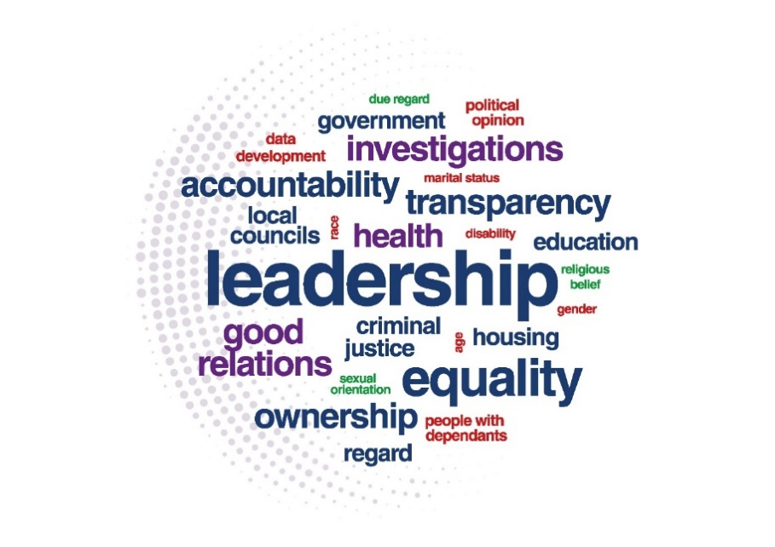

SECTION 75
DEMONSTRATING EFFECTIVE LEADERSHIP
SELF AUDIT CHECKLIST

Purpose of this audit

Leadership and commitment provided at the highest levels in a public authority, by the Minister and Permanent Secretary or the Chair and Chief Executive, are critical to the successful implementation and achievement of the intended outcomes of the Section 75 duties.
The roles of Management Boards and Senior Management Teams are also essential in ensuring that a meaningful and effective approach to implementing the Section 75 duties is adopted across the organisation.
The objective of this audit is to enable senior managers and Board members in public authorities to be assured that Section 75 is being effectively implemented, that they are adhering to their equality scheme commitments and to identify any areas where improvements may be made.
The audit is based on the Section 75: Demonstrating effective leadership guidance and it may be helpful to be familiar with this advice before completing the audit.
It is recommended that the audit be undertaken regularly, as part of a public authority’s assessment of its own compliance with the Section 75 duties, for example as part of the public authority’s Section 75 annual progress report. It is recognised that each public authority has its own internal governance arrangements and completion of the audit may be dependent on these arrangements.

www.equalityni.org/S75duties

DEMONSTRATING GOOD GOVERNANCE
SELF AUDIT CHECKLIST QUESTIONS | SUMMARY OF  CURRENT PRACTICES | ARE ANY ACTIONS NEEDED?  IF YES, PLEASE OUTLINE | BY WHOM | BY WHEN
1. Responsibilities and Resources

(a) Are key responsibilities for Section 75 allocated to:
- A specific senior board member to ensure accountability
- All policy makers with screening responsibilities
- An equality unit/officer to coordinate?

(b) Are resources allocated to Section 75 work?

2. Have the Section 75 duties been integrated into core business activities? e.g.
- Corporate / business plans
- Staff objectives
- Progress reports, and
- Risk registers?

3. Training

(a) Have all equality scheme training commitments been implemented?

(b) Have you considered including appropriate mandatory training e.g.
- For policymakers who will be undertaking screening/EQIA and
- For new staff via the induction process?

4. Section 75 Data / Evidence

(a) Is Section 75 data / evidence routinely collected to inform policy development and equality assessments (screening/EQIA)?

(b) Post implementation, are policies monitored to assess impact on Section 75 groups?

5. Is the implementation of the Section 75 commitments considered regularly by leaders/senior managers in their review of :
- Quarterly screening reports
- Section 75 annual progress report?

DEMONSTRATING EFFECTIVE AND MEANINGFUL EQUALITY ASSESSMENTS
SELF AUDIT CHECKLIST QUESTIONS | SUMMARY OF  CURRENT PRACTICES |  | ARE ANY ACTIONS NEEDED?  IF YES, PLEASE OUTLINE |  | BY WHOM | BY WHEN
6. Are all new or revised policies screened and/or equality impact assessed, as defined in the equality scheme?

If equality assessments are not provided, do decision makers ask for them?

7. Are senior officers satisfied that equality assessments (screening / EQIA) are :

(a) Timely? i.e.
- An integral part of the policy development process and not completed as an afterthought

(b) Good quality? i.e.
- Seek out ways of promoting equality and good relations
- Consider alternative policies or mitigation
- Consultation/engagement with S.75 groups
- Include planned Section 75 monitoring mechanisms
- Have clearly identifiable impacts

(c) Coherent? i.e.
- The information presented leads to a coherent screening decision

(d) Evidence based? i.e.
- The assessments include sufficient Section 75 data/evidence

(e) Proportionate? i.e.
- The level of assessment is proportionate to the policies’ potential impact on people

If the above appropriate equality information is not provided in screening/EQIA assessments, do decision-makers ask for it?

8. Do screening/EQIA assessments cover equality and good relations duties, as appropriate?

DEMONSTRATING EFFECTIVE COMMUNICATION AND ENGAGEMENT
SELF AUDIT CHECKLIST QUESTIONS | SUMMARY OF  CURRENT PRACTICES | ARE ANY ACTIONS NEEDED?  IF YES, PLEASE OUTLINE | BY WHOM | BY WHEN
9. Is the importance of, and commitment to, the Section 75 duties regularly communicated with all stakeholders
- Internally, and
- Externally?

10. Is the equality unit/manager supported by leadership to provide an internal quality assurance function to ensure equality scheme commitments are met?
e.g. are they enabled to:

- Query with policy officers the quality and timeliness of equality assessments and request reviews to be completed?

- Request that screening/EQIA is undertaken where they are aware that this is not happening?

11. Does the public authority work with other public authorities to implement the duties e.g. where they also have a role in developing or implementing a policy?

12. Is there effective consultation with those affected by policies (Section 75 groups and affected individuals), as policies are being developed?

13. Is there transparency of decision-making evidenced by the timely recording, publishing and communication of:
- Screening and EQIA exercises,
- Screening reports, and
- Monitoring information?

DEMONSTRATING EFFECTIVE ACTIONS TO ADDRESS PERSISTENT INEQUALITIES
SELF AUDIT CHECKLIST QUESTIONS | SUMMARY OF  CURRENT PRACTICES | ARE ANY ACTIONS NEEDED?  IF YES, PLEASE OUTLINE | BY WHOM | BY WHEN
14. Is a current Section 75 action plan in place?

If Yes,
- Is it based on a robust audit of inequalities?
- Does it include current and appropriate data?
- Does the plan have actions which focus on impacts and outcomes of the promotion

of equality of opportunity and good relations?, and
- Is the action plan effectively monitored for outcomes on the Section 75 groups?

If a current Section 75 action plan is not in place, is there a commitment to develop one?

OVERALL ASSESSMENT
SELF AUDIT CHECKLIST QUESTIONS | SUMMARY OF  CURRENT PRACTICES | ARE ANY ACTIONS NEEDED?  IF YES, PLEASE OUTLINE | BY WHOM | BY WHEN
Having completed this audit, overall are you satisfied that your equality scheme commitments are being implemented by:
- Senior managers
- Board members
- Policy makers
- Decisions makers
- Equality officers?

For further information on Demonstrating Effective Leadership visit our website
Section 75 duties

